**Hunger Bites**

**A PROJECT REPORT**

**for**

**Mini Project-I (K24MCA18P)**

**Session (2024-25)**

**Submitted by**

**Priyam Sharma**

**(University Roll No 202410116100)**

**Shalini Mishra**

**(University Roll No 202410116100192 )**

**Ram Dubey**

**(University Roll No 202410116100 )**

**Submitted in partial fulfilment of the**

**Requirements for the Degree of**

**MASTER OF COMPUTER APPLICATION**

**Under the Supervision of**

**Ms. Divya Singhal**

### Assistant Professor



**Submitted to**

**Department Of Computer Applications**

**KIET Group of Institutions, Ghaziabad**

**Uttar Pradesh-201206**

**(december- 2024)**

**I**

**CERTIFICATE**

Certified that **Priyam Sharma(202410116100151), Shalini Mishra (202410116100192)**,**Ram Dubey(202410116100158)** has/ have carried out the project work having “**Hunger Bites**” (**Mini Project-I, K24MCA18P**) for **Master of Computer Application** from Dr. A.P.J. Abdul Kalam Technical University (AKTU**)** (formerly UPTU), Lucknow under my supervision. The project report embodies original work, and studies are carried out by the student himself/herself and the contents of the project report do not form the basis for the award of any other degree to the candidate or to anybody else from this or any other University/Institution.

**Ms. Divya Singhal Dr. Arun Kr. Tripathi**

**Assistant Professor Head**

**Department of Computer Applications Department of Computer Applications**

**KIET Group of Institutions, Ghaziabad KIET Group of Institutions, Ghaziabad**

**II**

**ABSTRACT**

The Hunger Bites project aims to address the issue of hunger and food insecurity in rural communities. It focuses on creating an accessible platform for people in underserved areas to find local resources such as food banks, community kitchens, and government programs. By leveraging technology, this project seeks to bridge the gap between available food resources and the individuals in need, providing real-time updates on food distribution and availability. Through collaborations with local NGOs and government bodies, Hunger Bites will ensure a steady supply of nutritious food and offer educational content on nutrition and food management. The platform’s main objective is to alleviate hunger by empowering communities with the tools and information they need to access essential resources. Furthermore, the project will encourage volunteerism and community participation, fostering a supportive environment for tackling food insecurity. By addressing these key issues, Hunger Bites hopes to create a sustainable and scalable solution for food insecurity in rural areas.

**Keywords**: Hunger, Food Insecurity, Rural Communities, Technology, Resource Distribution

**III**

**ACKNOWLEDGEMENTS**

Success in life is never attained single-handedly. My deepest gratitude goes to my project supervisor, **Ms. Divya Singhal** for her guidance, help, and encouragement throughout my project work. Their enlightening ideas, comments, and suggestions.

Words are not enough to express my gratitude to Dr. Arun Kumar Tripathi, Professor and Dean, Department of Computer Applications, for his insightful comments and administrative help on various occasions.

Fortunately, I have many understanding friends, who have helped me a lot on many critical conditions.

Finally, my sincere thanks go to my family members and all those who have directly and indirectly provided me with moral support and other kind of help. Without their support, completion of this work would not have been possible in time. They keep my life filled with enjoyment and happiness.

**Priyam Sharma**

**Shalini Mishra**

**Ram Dubey**

# **TABLE OF CONTENTS**

|  |
| --- |
| Certificate I |
| Abstract II |
| Acknowledgements III |

|  |  |  |  |  |  |  |  |
| --- | --- | --- | --- | --- | --- | --- | --- |
| **Chapter 1: Introduction** | | | | | | | |
| 1.1 | | Background | | | | 1 | |
| 1.2 | | Objectives | | | | 2 | |
| 1.3 | | Purpose, Scope and Applicability | | | | 3 | |
|  | | 1.3.1 | | | Purpose | 3 | |
| 1.3.2 | | | Scope | 3 | |
| 1.3.3 | | | Applicability | 4 | |
| 1.4 | | Current Challenges | | | | 5 | |
| 1.5 | | Opportunities Of Improvement | | | | 6-7 | |
| 1.6 | | Feature Of Hunger Bites | | | | 8 | |
| 1.7 | | Project Goals And Objectives | | | | 9 | |
| 1.8 | | Promoting Sustanibility | | | | 10 | |
| 1.9 | | Scope Of Project | | | | 11 | |
| 1.10 | | Changes And Solutions | | | | 12 | |
| 1.11 | | Conclusion | | | | 13 | |
| **Chapter 2: Feasibility Study** | | | | | | | |
| 2.1 | | **Economic Viability** | | | | 15 | |
| 2.2 | | Technical Feasibility | | | | 16 | |
| 2.3 | | Market Analysis | | | | 17 | |
| 2.4 | | Social Impact Assessment | | | | 18 | |
| 2.5 | | Enviromental Consideration | | | | 19 | |
| **Chapter 3: Project Object** | | | | | | | |
| 3.1 | | Project Objective | | | | 20-21 | |
|  | | **Chapter 4: Hardware and Software Requirement** | | | |  | |
|  | | 4.1 | | | Software Requirements | 22 | |
| 4.2 | | | Hardware Requirements | 23 | |
|  | | **Chapter 5: Project Flow** | | | | 24 | |
|  | | 5.1 | | Flow Chart Diagram 25-27 | | | |  |
|  | | 5.2 | Use Case Diagram | | | 28 |
| 5.3 | Entity Relationship Diagram | | | 29 |
| 5.4 | User Interface | | | 30-37 |
|  | | | **Chapter** **6: Project Outcome** | | | 40-41 | |
| 6.1 | | | Reference | | | 40-41 | |

**Chapter 1**

**Introduction**

In today’s fast-paced world, convenience is key, especially when it comes to something as essential as food. The Hunger Bites app is designed to make food delivery and management easier and more efficient for everyone involved—customers, restaurants, and delivery partners.

For customers, it’s a one-stop solution where they can browse their favorite restaurants, place orders effortlessly, track their food in real time, and make secure payments. Restaurants benefit from tools that help them manage orders smoothly, optimize their operations, and enhance customer satisfaction. On the other hand, delivery partners are provided with intuitive features like route optimization and order management, ensuring faster and more efficient deliveries.

What makes Hunger Bites stand out is its focus on creating a seamless, user-friendly experience while also promoting sustainability. The app includes features that minimize food wast encourage eco-friendly practices, and support small businesses by providing them with a platform to reach more customers.

In essence, Hunger Bites bridges the gap between technology and food delivery, simplifying the process while making it more accessible, reliable, and beneficial for everyone involved. The app isn’t just about delivering meals—it’s about creating an ecosystem that values convenience, efficiency, and sustainability.

* 1. **Overview**

Hunger Bites is a food delivery and management app created to make ordering food easier and more efficient for everyone involved—customers, restaurants, and delivery partners. The app aims to solve common problems like late deliveries, slow restaurant operations, and lack of transparency for users.

For customers, Hunger Bites offers features like real-time tracking to know exactly where their food is, secure payment options, and a feedback system to share their experiences. Restaurants can use the app to manage orders more smoothly, improve kitchen workflows, and keep track of customer reviews. Delivery partners get tools to plan the best routes, save time, and make more deliveries efficiently.

What makes Hunger Bites special is its focus on sustainability and community support. It helps reduce food waste through better inventory tracking and encourages the use of eco-friendly packaging. The app also empowers small businesses by giving them a platform to reach more customers without big costs.

Overall, Hunger Bites is more than just a food delivery app—it’s designed to create a better experience for users, support local businesses, and take care of the environment, all in one platform.

**1.2.Background**

In today’s busy world, food delivery has become a huge part of our daily lives. People love the convenience of ordering food online, but this booming industry still has its fair share of challenges. Delayed deliveries, messy order management, and a lack of transparency often leave customers frustrated. On the other side, restaurants struggle to handle orders efficiently, and delivery workers face difficulties like poor route planning and low earnings.

That’s where Hunger Bites comes in. The idea behind this app is to create a platform that makes food delivery smoother for everyone involved—customers, restaurants, and delivery partners. By using modern technology, the app solves common issues like delivery delays and improves the overall experience for users.

But Hunger Bites is not just about convenience. It also focuses on making a positive impact. The app encourages eco-friendly practices like reducing food waste and using biodegradable packaging to help the environment. It also gives small businesses an affordable way to grow and reach more customers.

The story behind Hunger Bites shows why this app is needed—not just to fix everyday problems, but also to support the community and protect the environment.

**1.3.Purpose, Scope, and Applicability of Hunger Bites**

#### **Purpose**

The purpose of Hunger Bites is to revolutionize the food delivery ecosystem by providing a seamless, user-friendly platform that connects customers, restaurants, and delivery partners. It aims to simplify the ordering and delivery process, enhance restaurant operations, and create meaningful employment opportunities. By incorporating advanced technology and sustainability practices, Hunger Bites addresses modern-day challenges in food delivery, ensuring convenience, efficiency, and customer satisfaction.

#### **Scope**

Hunger Bites serves a wide range of users and stakeholders, ensuring adaptability and scalability:

* **Customers**: Provides a diverse selection of cuisines, personalized recommendations, real-time tracking, and secure payment options for an enjoyable experience.
* **Restaurants**: Assists businesses of all sizes—from global chains to local eateries—with tools for order management, analytics, and menu optimization.
* **Delivery Partners**: Supports delivery personnel with route optimization, transparent compensation, and flexible work schedules.
* **Geographical Reach**: Designed for both urban and suburban markets, ensuring accessibility even in less-served regions.
* **Sustainability**: Incorporates eco-friendly practices, like optimizing delivery routes and promoting sustainable packaging.

This scope enables Hunger Bites to effectively cater to diverse needs and expand to new markets, while supporting the growth of small businesses and the gig economy.

#### **Applicability**

Hunger Bites is applicable across multiple domains and scenarios:

* **Food Delivery**: Facilitates quick and reliable delivery services for customers, covering a wide variety of cuisines and dietary preferences.
* **Restaurant Management**: Helps restaurants streamline operations, improve customer outreach, and increase revenue through data-driven tools.
* **Employment Generation**: Provides opportunities for delivery personnel, enhancing the gig economy by offering flexible and fair work conditions.
* **Sustainability Efforts**: Aligns with environmental goals by reducing carbon footprints through optimized delivery routes and encouraging eco-friendly packaging.
* **Technology Integration**: Showcases the use of advanced technologies like AI-powered route optimization, secure payment systems, and real-time tracking, making it a modern solution for food delivery challenges.

Hunger Bites is purpose-driven, wide in scope, and applicable across a variety of user needs, ensuring a balanced ecosystem that benefits all stakeholders involved in the food delivery chain.

* 1. **Current Challenges in Food Delivery**

The food delivery industry has become an essential part of modern life, but it still faces several significant challenges that affect customers, restaurants, and delivery personnel alike.

1. **Delayed Deliveries:** Customers often experience frustration due to delays caused by inefficient order handling, traffic conditions, or poor route planning. These delays impact customer satisfaction and loyalty.
2. **Lack of Transparency:** Many platforms fail to provide real-time updates, leaving customers unsure about their order status and delivery timelines. This lack of communication leads to distrust in the service.
3. **Restaurant Operations:** Restaurants struggle with managing high order volumes during peak times, leading to miscommunication, delays, and lower-quality service.
4. **Delivery Partner Issues:** Delivery personnel frequently face challenges such as unoptimized delivery routes, unpredictable schedules, and insufficient earnings, reducing their overall efficiency and job satisfaction.
5. **Environmental Concerns:** Food delivery often involves excessive use of plastic and non-biodegradable materials, contributing to environmental pollution. Additionally, food wastage due to improper inventory management remains a pressing concern.

These challenges underline the need for a comprehensive solution that not only enhances operational efficiency but also focuses on improving customer experience, supporting delivery personnel, and addressing environmental issues. Hunger Bites was developed to tackle these pain points, ensuring a seamless and sustainable food delivery ecosystem for everyone involved.

**1.5. Opportunities for Improvement**

• **Better User Experience**

* **What’s the problem?** The app may be hard to use for some people.
* **What can be improved?** Make the app easier to navigate and more visually appealing for all users, even those who aren't tech-savvy.

• **Faster Delivery Times**

* **What’s the problem?** Sometimes food takes longer to deliver, which can upset customers.
* **What can be improved?** Use better tools to find the quickest delivery routes or work with more local delivery people to make sure food arrives on time.

• **More Restaurant Choices**

* **What’s the problem?** There might not be enough restaurant options or variety in the menu.
* **What can be improved?** Add more restaurants, especially those offering different types of food like vegan or gluten-free, to attract more customers.

• **More Payment Options**

* **What’s the problem?** The app might not offer enough ways to pay.
* **What can be improved?** Add more payment options, like wallets or QR code payments, and make sure all transactions are secure.

• **Faster Customer Support**

* **What’s the problem?** Customers may have to wait too long for help.
* **What can be improved?** Offer quicker support by adding live chat in the app and making sure customers get help faster.

• **Better Marketing**

* **What’s the problem?** The app might not be keeping customers interested.
* **What can be improved?** Create loyalty programs or offer discounts to keep users coming back.

• **Environmentally Friendly Packaging**

* **What’s the problem?** Delivery packaging may create a lot of waste.
* **What can be improved?** Use eco-friendly packaging and encourage restaurants to do the same.

• **Personalized Recommendations**

* **What’s the problem?** The app may not suggest food based on what users like.
* **What can be improved?** Use data to recommend meals based on what the user orders most often.

### 1.6.Features of Hunger Bites

1. **Easy Food Ordering**
   * You can easily browse through different restaurants and food items and place your order with just a few taps.
2. **Multiple Payment Options**
   * The app lets you pay using different methods like credit/debit cards, wallets, or QR codes, making it easier for everyone to pay in their preferred way.
3. **Order Tracking**
   * You can track your food from the moment you place the order until it reaches your doorstep, so you know when to expect it.
4. **Restaurant Choices**
   * There are a variety of restaurants available on the app, offering different cuisines and types of food to satisfy every taste.
5. **Special Offers and Discounts**
   * The app provides special deals, discounts, and promotions to help save money on your orders.
6. **Customer Support**
   * If you face any issues or have questions, you can get help quickly through in-app chat or customer support.
7. **Ratings and Reviews**
   * After ordering, you can rate and review the restaurant and food, helping others make better choices.
8. **Personalized Recommendations**
   * Based on your past orders, the app suggests food you might like, making it easier to decide what to order next.
9. **Fast Delivery**
   * The app works with local delivery partners to get your food to you as quickly as possible.
10. **Environmentally Friendly Packaging**

* Hunger Bites uses eco-friendly packaging to reduce waste, helping the environment.

### 1.7. Project Goals and Objectives

1. **Goal: Provide Easy Access to Food**
   * **Objective:** Make sure users can quickly find and order food from a variety of restaurants using the app.
2. **Goal: Ensure Fast and Reliable Delivery**
   * **Objective:** Partner with reliable delivery services to make sure food arrives on time and in good condition.
3. **Goal: Offer Multiple Payment Options**
   * **Objective:** Allow users to pay using different methods like cards, wallets, or QR codes, to make transactions easy for everyone.
4. **Goal: Improve User Experience**
   * **Objective:** Make the app easy to use and navigate, with a simple design that works for all types of users.
5. **Goal: Provide Customer Support**
   * **Objective:** Offer fast and helpful customer support to resolve any issues that users face.
6. **Goal: Promote Healthy and Sustainable Choices**
   * **Objective:** Encourage restaurants to offer healthy menu options and use eco-friendly packaging to reduce waste.
7. **Goal: Build Customer Loyalty**
   * **Objective:** Create loyalty programs, discounts, and offers that keep customers coming back for more.
8. **Goal: Gather and Use Feedback**
   * **Objective:** Collect feedback from users to improve the app, add new features, and make the service better over time.

### 1.8. Promoting Sustainability

1. **Eco-friendly Packaging**
   * We use packaging that’s good for the environment, like biodegradable or recyclable materials, to reduce waste from food deliveries.
2. **Reducing Carbon Footprint**
   * By partnering with local restaurants and delivery services, we help cut down on long-distance travel, which reduces pollution and helps the planet.
3. **Promoting Healthy Eating**
   * We encourage restaurants to offer healthier food options, so users can make better food choices that are good for their health and the environment.
4. **Waste Reduction Programs**
   * We’re working with restaurants to reduce food waste, like offering smaller portion sizes or donating unsold food to local charities.
5. **Supporting Sustainable Restaurants**
   * We aim to partner with restaurants that follow sustainable practices, such as sourcing ingredients locally or using energy-efficient equipment.

By focusing on these actions, Hunger Bites is committed to doing its part in protecting the environment while providing a great food delivery service.

### 1.9. Scope of the Project

1. **Food Delivery Services**
   * The app will provide food delivery from a variety of local restaurants to customers. Users can choose from different cuisines and place orders easily.
2. **Geographical Reach**
   * Initially, the app will focus on serving customers in a specific city or region, with plans to expand to more areas over time.
3. **Target Users**
   * The app is designed for anyone who wants to order food online. It will cater to people who are looking for convenience, variety, and quick delivery.
4. **Restaurant Partnerships**
   * Hunger Bites will work with local restaurants to offer a wide range of food options. Restaurants will be able to sign up and list their menus on the app.
5. **Payment and Delivery**
   * The app will support multiple payment methods (like cards, wallets, and QR codes) and will have a system in place for reliable delivery.
6. **Customer Support**
   * Users will have access to customer support through the app for any issues with their orders, payments, or app features.
7. **Sustainability Initiatives**
   * The app will focus on eco-friendly packaging and encourage restaurants to reduce food waste, aiming to have a positive impact on the environment.
8. **Marketing and Promotions**
   * The app will include features like discounts, promotions, and loyalty programs to attract and retain customers.

The project focuses on creating an easy-to-use, reliable food delivery service with a goal of making a positive impact on both customers and the environment.

### 1.10. Challenges and Solutions

1. **Challenge: Late Deliveries**
   * **Solution:** Partner with more local delivery drivers and use better route planning to ensure food arrives on time.
2. **Challenge: Limited Restaurant Choices**
   * **Solution:** Work with more restaurants and include options for different types of food like vegan or gluten-free, so customers have more choices.
3. **Challenge: Payment Issues**
   * **Solution:** Add more payment options (like credit/debit cards, wallets, QR codes) and make sure all transactions are secure to avoid problems during payments.
4. **Challenge: Customer Support Delays**
   * **Solution:** Set up faster and more efficient customer support through live chat, so users can get help quickly if there’s an issue.
5. **Challenge: Waste from Packaging**
   * **Solution:** Use eco-friendly packaging like biodegradable or recyclable materials to reduce waste and promote sustainability.
6. **Challenge: Attracting New Users**
   * **Solution:** Offer discounts, special deals, and a loyalty program to keep customers interested and encourage them to order again.
7. **Challenge: Handling High Traffic**
   * **Solution:** Make sure the app’s servers can handle lots of users at once, especially during peak times, so the app doesn’t crash or slow down.

By identifying these challenges early, Hunger Bites can take steps to solve them and improve the overall customer experience.

**Chapter 2**

**Feasibility Study**

A feasibility study helps us understand if *Hunger Bites* is a good idea and if it can be successful. It looks at different aspects like the market, technology, operations, finances, and legal requirements to see if the app can work in the real world.

The **market feasibility** shows that there is a high demand for food delivery services. Many people are looking for an easy way to order food, especially with busy schedules, so launching a food delivery app is a good idea.

The **technical feasibility** proves that the technology needed to build and run the app is available and works well. There are many tools and systems that can help create the app, manage payments, track deliveries, and offer customer support, so the technology is ready.

The **operational feasibility** shows that the app can be run smoothly by partnering with local restaurants and delivery drivers. With the right resources and a good team, *Hunger Bites* can provide fast and reliable service.

The **financial feasibility** indicates that while there will be costs to develop the app and run the business, there is a good chance of making money through delivery fees, restaurant partnerships, and customer loyalty programs. The app can be profitable with a solid financial plan.

Finally, the **legal feasibility** shows that the app must follow laws related to food safety, business licenses, and customer privacy. As long as these legal requirements are met, the app can operate without issues.

Overall, the feasibility study shows that *Hunger Bites* has a good chance of being successful. There’s strong demand for food delivery, the technology is available, and with the right resources, the app can operate smoothly and make a profit.

### 2.1 Economic Viability

Economic viability looks at whether Hunger Bites can make enough money to cover its costs and be profitable. It involves understanding the expenses needed to run the app and comparing them with the potential income it can generate.

To start, the main costs will be developing the app, setting up payment systems, marketing the app, and paying delivery drivers and restaurant partners. These expenses are necessary to get the business running smoothly.

On the income side, Hunger Bites will earn money from delivery fees, which customers pay when they place an order. The app can also make money through partnerships with restaurants, charging them a small fee for listing their menu on the platform. In addition, offering loyalty programs and special deals can encourage repeat customers and boost sales.

Based on these factors, Hunger Bites has the potential to make a profit, especially as it attracts more users and expands to new areas. With careful planning, the app can cover its costs and generate enough income to keep growing and succeed in the long term.

### 2.2 Technical Feasibility

Technical feasibility looks at whether the technology needed to create and run Hunger Bites is available and can work as expected. It checks if the tools, systems, and software required to build the app and support its features are ready to use.

For Hunger Bites, the technology needed includes building a user-friendly app that allows customers to browse menus, place orders, and track deliveries. The app also needs a secure payment system, customer support features, and a way to connect with restaurants and delivery drivers.

Luckily, there are many existing tools and platforms that make building such an app easier. Payment systems like credit cards, wallets, and QR codes are widely available, and there are reliable services for tracking deliveries and providing customer support. The technology needed for the app is already tested and ready to use.

Overall, the technical feasibility shows that the technology required to build Hunger Bites is available, and the app can be developed smoothly with the right technical resources.

### 2.3 Market Analysis

The food delivery market is growing rapidly, with more people seeking convenience, especially busy professionals, students, and families. They prefer online food ordering because it saves time, and Hunger Bites can meet this demand by providing a simple and quick service.

However, there are strong competitors like Uber Eats, Swiggy, and Zomato already operating in the market. Despite the competition, Hunger Bites has an opportunity to stand out by focusing on offering better customer service, local restaurant partnerships, and unique features such as eco-friendly packaging and healthier food options.

There is also a rising trend for healthier eating and sustainable practices, which customers value more nowadays. Hunger Bites can tap into this trend by offering more plant-based, gluten-free, or low-calorie choices and promoting sustainability, making it an appealing choice for eco-conscious consumers.

The app can also offer personalized experiences and rewards through loyalty programs, which will help retain customers and encourage repeat orders.

While the market is competitive, there is a significant demand for food delivery services, especially when offering something unique. With the right focus on customer needs, sustainability, and local partnerships, Hunger Bites has the potential to grow and become a strong player in the market.

### 2.4 Social Impact Assessment

A social impact assessment examines how Hunger Bites, a food delivery app, can affect society, local communities, and the environment. It helps to understand the positive changes the app could bring.

**Support forLocal Businesses**  
One of the key benefits of Hunger Bites is that it helps local restaurants. Small restaurants that cannot afford to set up their own delivery service can partner with the app to reach more customers. This increases their sales and helps them stay in business. The app also creates job opportunities for delivery drivers, customer support staff, and other workers, contributing to the local economy.

**Improved Food Accessibility**  
Hunger Bites makes food more accessible to people who may not have easy access to restaurants. People who are elderly, disabled, or have busy schedules can use the app to order food without having to leave their homes. This helps those who may have difficulty going out to eat or cooking their own meals.

**Promoting Sustainability**  
Hunger Bites can also have a positive impact on the environment. By using eco-friendly packaging and encouraging restaurants to adopt sustainable practices, the app helps reduce waste. Customers are also encouraged to make more sustainable choices, such as ordering from restaurants that focus on using less plastic and more eco-friendly materials.

**Enhancing Customer Convenience**  
The app improves the quality of life by offering a convenient and quick way to order food. People with busy lives can save time and enjoy a variety of food options delivered straight to their door. This makes life easier for individuals and families, providing them with more free time and less stress.

In conclusion, Hunger Bites has the potential to positively impact communities by supporting local businesses, improving food accessibility, promoting sustainability, and making life more convenient for its customers.

### 2.5 Environmental Considerations

Environmental considerations look at how Hunger Bites, a food delivery app, can impact the environment and what actions can be taken to reduce any negative effects.

**Eco-friendly Packaging**  
One of the biggest environmental impacts of food delivery is packaging waste. Hunger Bites can reduce its environmental footprint by using eco-friendly packaging, such as biodegradable or recyclable materials. This helps reduce plastic waste, which is harmful to the environment. Encouraging restaurants to use these types of packaging can also make a big difference.

**Reducing Food Waste**  
Another important consideration is food waste. Sometimes, food that is ordered is not consumed, leading to waste. Hunger Bites can help reduce this by offering smaller portion sizes or allowing customers to customize their orders more easily. It can also promote partnerships with organizations that donate leftover food to those in need, reducing waste and helping the community.

**Delivery Efficiency**  
The app's delivery system can also impact the environment, especially with many vehicles on the road. Hunger Bites can reduce its carbon footprint by using electric bikes or cars for deliveries. By optimizing delivery routes, the app can also reduce fuel consumption and the number of vehicles on the road, making the service more eco-friendly.

**Encouraging Sustainable Choices**  
The app can help customers make more sustainable choices by featuring restaurants that focus on sustainability, like those that use locally sourced ingredients or follow eco-friendly practices. Customers can choose to order from these restaurants, which supports businesses that prioritize the environment.

Overall, Hunger Bites has the opportunity to reduce its environmental impact by using eco-friendly packaging, minimizing food waste, optimizing deliveries, and promoting sustainable choices for its customers.

### Chapter 3

### Project Objective

The main objective of the Hunger Bites project is to create a food delivery app that makes it easy for people to order food from local restaurants. The app aims to improve convenience, food accessibility, and sustainability for customers while supporting local businesses.

**1. Providing Convenience:**  
The app’s primary goal is to offer a simple, fast, and user-friendly way for customers to order food. It should be easy for anyone to browse menus, place orders, and track deliveries. This saves customers time and effort, especially for those with busy schedules who prefer not to cook or go out to eat.

**2. Supporting Local Restaurants:**  
A key objective is to help local and small restaurants grow by providing them a platform for food delivery. Many small restaurants may not have the resources to set up their own delivery systems, so Hunger Bites can help them reach more customers and increase their sales. This also creates job opportunities for restaurant staff and delivery drivers.

**3. Promoting Sustainability:**  
Hunger Bites is committed to sustainability. The app aims to reduce its environmental impact by using eco-friendly packaging and encouraging restaurants to adopt greener practices. By promoting responsible choices, such as reducing plastic waste and supporting eco-conscious restaurants, the app can help raise awareness about sustainability in the food industry.

**4. Job Creation:**  
The app also aims to create new job opportunities in areas such as delivery, customer service, and app management. This helps support the local economy and provide employment to people in the community.

**5. Improving Customer Experience:**  
Another important goal is to enhance the customer experience. The app will offer personalized recommendations, fast deliveries, and reliable customer service to ensure that users enjoy their experience every time they order.

In conclusion, Hunger Bites aims to provide a convenient, reliable, and sustainable food delivery service that benefits customers, local businesses, and the environment, while creating job opportunities and improving the overall food delivery experience.

**Chapter4**

### Hardware and Software Requirements

To build and run the Hunger Bites food delivery app successfully, certain hardware and software tools are necessary to ensure smooth operations and a good user experience.

**4.1 Hardware Requirements:**

1. **Servers:**  
   The app requires reliable servers to store data, process orders, and handle customer requests. These servers will ensure that the app works without interruptions, even during busy times, by handling large amounts of data and user interactions.
2. **Smartphones/Tablets:**  
   The app needs to be accessible on smartphones and tablets for both customers and delivery drivers. Customers use their phones to browse menus, place orders, and track deliveries. Delivery drivers need devices to receive orders, navigate routes, and confirm deliveries. The app must work smoothly on Android and iOS devices.
3. **Computers:**  
   Restaurant managers or owners will need computers to access the app’s admin panel. They will use the computers to update menus, manage orders, and monitor deliveries. The system should be web-based so that it is easy to access from any location.
4. **Internet/ Connection:**  
   A fast and stable internet connection is crucial for the app’s functionality. Both customers and restaurant staff need reliable internet to place orders, make payments, and track deliveries in real time.

**4.2 Software Requirements:**

1. **Mobile Application:**  
   The app should be available for Android and iOS users. Key features should include browsing restaurant menus, placing and customizing orders, making payments, tracking deliveries, and providing feedback.
2. **Database Management System (DBMS):**  
   A strong database system is required to store user profiles, restaurant data, orders, payments, and delivery details. It will help organize and retrieve data quickly for smooth operation.
3. **Payment Gateway:**  
   To ensure secure payments, the app needs to integrate a payment gateway like PayPal, Stripe, or Razorpay. This allows users to pay through credit or debit cards, digital wallets, or other secure payment methods.
4. **Cloud Hosting:**  
   Cloud platforms like Amazon Web Services (AWS) or Google Cloud provide reliable hosting services. These platforms store data, ensure backups, and offer scalability as the app grows.
5. **Admin Dashboard:**  
   Restaurant owners and managers will use a web-based dashboard to manage their menus, track orders, and handle customer queries. This system helps in managing business operations and improving customer service.

These hardware and software requirements are essential to build and maintain the Hunger Bites app, ensuring it works efficiently for customers, restaurants, and delivery staff.

### Chapter 5

### Project Flow

The project flow for developing the Hunger Bites food delivery app follows a structured approach to ensure that all steps are completed efficiently and successfully. The methodology focuses on planning, development, testing, and launch to deliver a high-quality app that meets user needs.

**1.Planning and Research:**  
The first step in the process is understanding the needs of customers and restaurants. This involves conducting market research to understand customer preferences, identifying competitors and analyzing trends in the food delivery industry. It also includes gathering requirements from local restaurants and ensuring they are interested in joining the platform. This stage helps define the app’s key features and design.

**2. Designing the App:**  
After gathering all necessary information, the next step is designing the user interface (UI) and user experience (UX). This involves creating wireframes and mockups of the app, which show how it will look and how users will interact with it. The goal is to make the app easy to use, visually appealing, and efficient for both customers and restaurant staff.

**3. Development:**  
Once the design is approved, the development team starts building the app. This involves coding the app for both Android and iOS platforms, integrating features like browsing menus, placing orders, making payments, and tracking deliveries. The backend, such as the database and server management, is also developed to store and manage data securely.

**4. Testing:**  
After development, the app undergoes thorough testing to identify and fix any bugs or issues. This includes functional testing to ensure all features work as expected, as well as performance testing to ensure the app works smoothly even during high traffic.

**5. Launch and Maintenance:**  
Once the app is tested and ready, it is launched in the market. After launch, continuous monitoring and updates are performed to improve features, fix any issues, and keep the app secure.

This structured approach helps ensure that Hunger Bites is developed with careful planning, thorough testing, and continuous improvement for a successful launch.

**5.1 Flow Chart Diagram**

Flowchart is a diagrammatic representation of sequence of logical steps of a program. Flowcharts use simple geometric shapes to depict processes and arrows to show relationships and process/data flow.

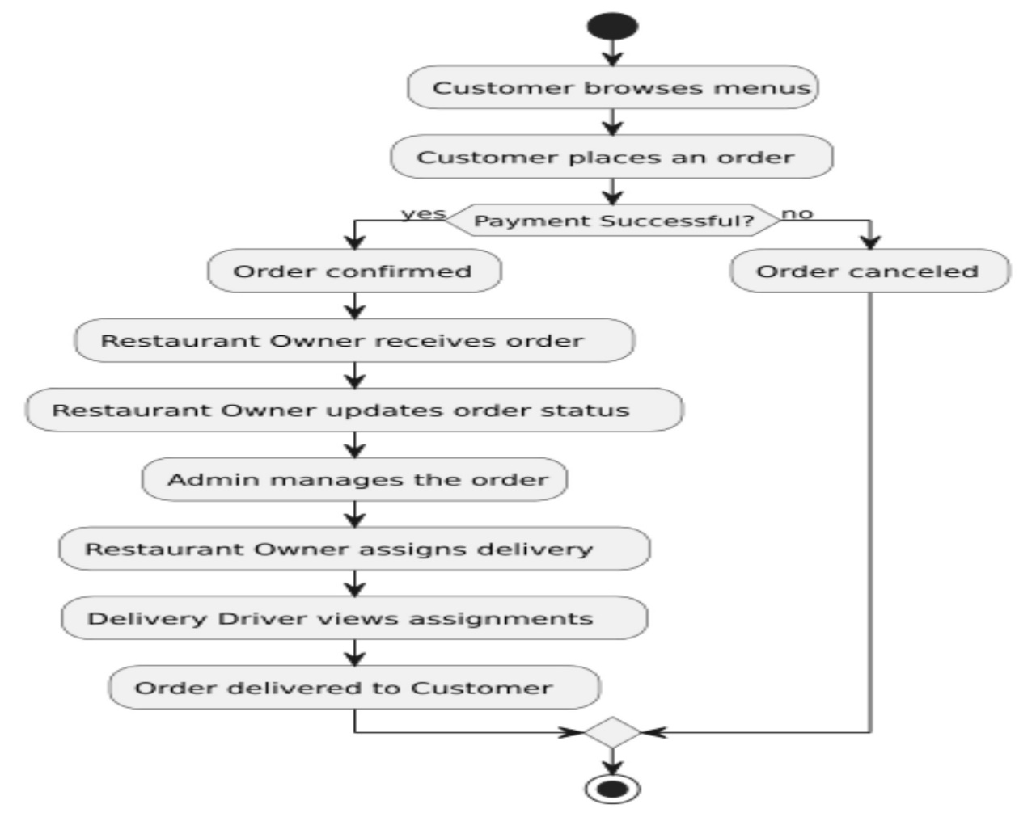

Fig 5.1 Flow chart Diagram

**Diagram Breakdown:**

**Customer:**

1. **Browse Menu:** Customer views the restaurant's menu, either online or in-person.
2. **Place Order:** Customer places an order through the restaurant's website, app, or in-person.
3. **Order Confirmation:** Customer receives an order confirmation.
4. **Order Tracking:** Customer tracks the order status.
5. **Order Delivery/Pickup:** Customer receives the order and provides feedback.

**Restaurant Owner:**

1. **Manage Menu:** Owner updates and maintains the restaurant's menu.
2. **Receive Orders:** Owner receives orders from customers.
3. **Order Fulfillment:** Owner prepares and packages the order.
4. **Assign Delivery:** Owner assigns the order to a delivery driver.
5. **Manage Orders:** Owner tracks orders and manages order fulfillment.

**Delivery Driver:**

1. **Receive Order Assignment:** Driver receives an order assignment from the restaurant owner.
2. **Order Pickup:** Driver picks up the order from the restaurant.
3. **Order Delivery:** Driver delivers the order to the customer.
4. **Order Confirmation:** Driver confirms order delivery.

**Admin:**

1. **System Management:** Admin manages the restaurant's online ordering system and app.
2. **User Management:** Admin manages customer and driver accounts.
3. **Order Management:** Admin monitors and manages all orders.
4. **Reporting:** Admin generates reports on order history, sales, and delivery performance.

**Interactions:**

* Customer interacts with the restaurant owner by placing orders and providing feedback.
* Restaurant owner interacts with the delivery driver by assigning orders and tracking deliveries.
* Delivery driver interacts with the customer by delivering orders and receiving confirmation.
* Admin interacts with all parties by managing the system, users, and orders.

**Additional Considerations:**

* Payment processing
* Order cancellations and refunds
* Special requests and dietary restrictions
* Customer support
* Marketing and promotions
* Inventory management

This flowchart provides a basic overview of the interactions between customers, restaurant owners, delivery drivers, and admins in a restaurant operation. The specific processes and interactions may vary depending on the restaurant's size, type, and technology infrastructure.

**5.2 Use Case Diagram**

Brouse Menue

Place Order

Make Payment

View Status Order

**customer**

Update Menue

Update Order Status

Manage order

**Resturant Owner**

Manage User

Assign Delivery

Fig 5.2 Use Case Diagram

**5.3 Entity Relationship Diagram**

1. ER model stands for an Entity-Relationship model. It is a high-level data model. This model is used to define the data elements and relationship for a specified system.
2. It develops a conceptual design for the database. It also develops a very simple and easy to design view of data.
3. In ER modelling, the database structure is portrayed as a diagram called an entity-relationship diagram.

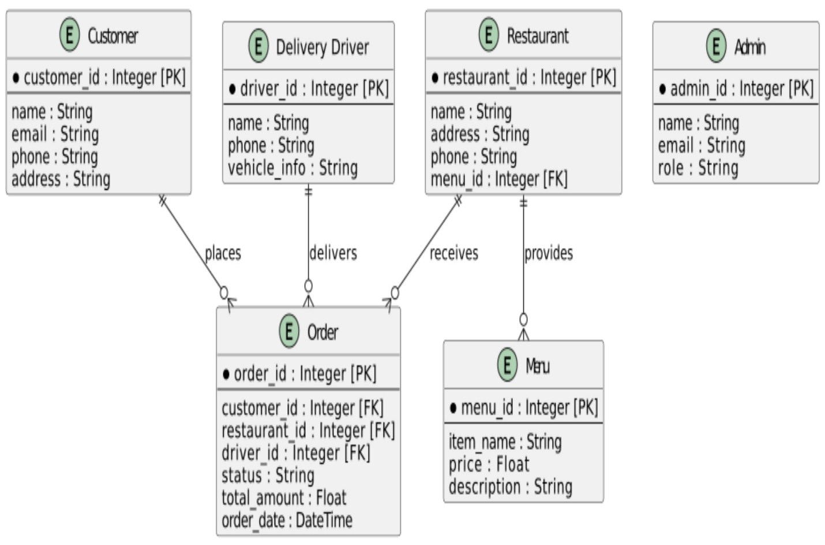

Fig 5.3 Entity Relationship Diagram

### 

**5.4 User Interface**

**5.4.1 Home Page:**

The **Hunger Bites** homepage is designed to make food ordering easy and quick. It grabs your attention with bright colors and delicious food pictures. Users can choose between delivery or pickup, enter their address, and find food with just a few clicks. The simple design and clear options make it easy for anyone to use, creating a smooth and enjoyable experience.

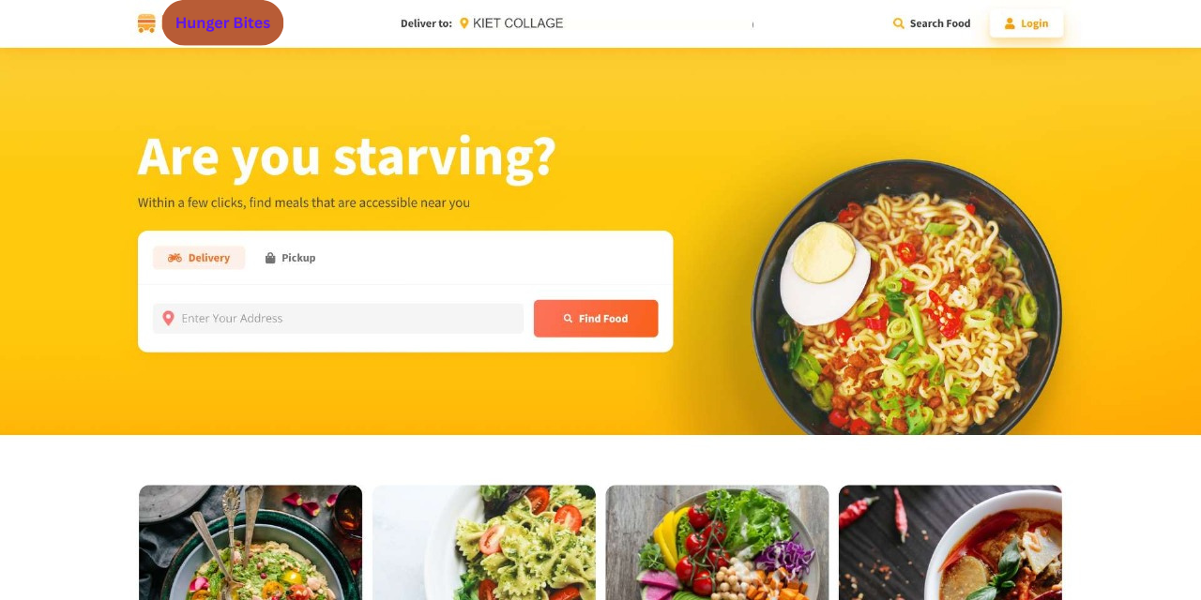

### ****5.4.2 Choose Delivery or Pickup****

* The interface allows you to select how you want to get your food:
  + **Delivery**: Food will be delivered to your entered address.
  + **Pickup**: You can choose to pick up your food from nearby restaurants.

### 5.4.3 ****Enter Your Address****

* There’s a search bar where you enter your current location or delivery address.
* Based on the address you provide, the system will locate nearby restaurants or food options.

### 5.4.4 ****Click "Find Food"****

* After entering your address, click the **"Find Food"** button.
* The platform searches its database of partner restaurants near the provided address.

### 5.4.5 ****Browse Food Options****

* The platform displays food categories or specific dishes available.
* You can scroll through the options (shown in the grid of dishes) and pick what you like.

### 5.4.6 ****Search or Login****

* Use the **search** icon to find specific cuisines, dishes, or restaurants.
* If you have an account, click **Login** to access saved preferences, orders, or payment methods.

### 5.4.7 ****Place an Order****

* After selecting your food, you proceed to checkout, where you:
  + Confirm your address or pickup location.
  + Choose payment options (e.g., online payment or cash on delivery).

**5.5 Cart Page:**

The **Cart Page** serves as a critical touchpoint in the customer journey, offering a user-friendly interface for managing reservations. This page dynamically displays a comprehensive list of all items the user has reserved, along with key details such as product names, quantities, individual prices, and the total price.

**Key Features:**

1. **Item List Display**:  
   Users can see all the items they’ve added to their cart in an organized table format, ensuring clarity and ease of navigation. Each row represents a reserved item, complete with its price and quantity.
2. **Editing Options**:
   * **Remove Items**: Customers can easily remove unwanted items with a single click, keeping their cart streamlined and relevant.
3. **Total Cost Calculation**:  
   A real-time summary calculates the total cost of all items in the cart, allowing users to make informed decisions before proceeding to checkout.

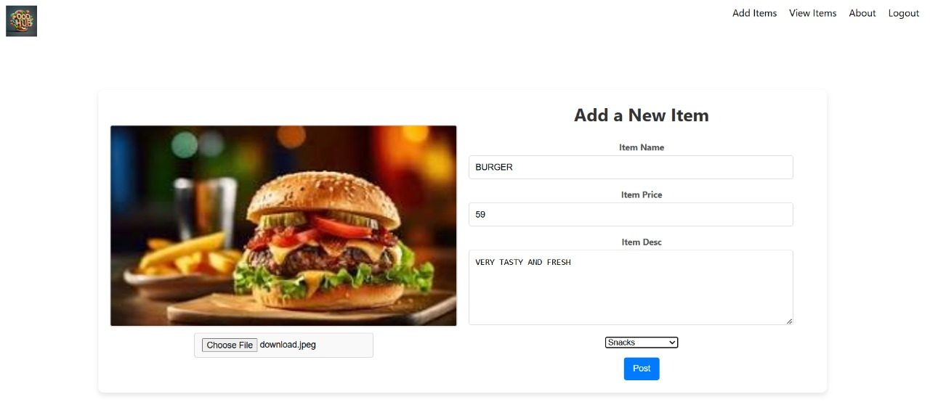

**5.6 Payment Page:**

**The Payment Page** of **Reserve and Ready** is designed to provide a seamless and secure checkout experience.

* **Form Fields**: Includes input fields for essential payment details:
  + Card number
  + Expiry date
  + CVV
  + Cardholder name
* **Pay Now Button**: A clearly visible **“Pay Now”** button ensures users can complete their transaction with ease.
* **Layout**: The page is clean, intuitive, and user-friendly, prioritizing simplicity to reduce friction in the payment process.
* **Security**: Emphasizes secure payment processing to build user trust and confidence in the platform

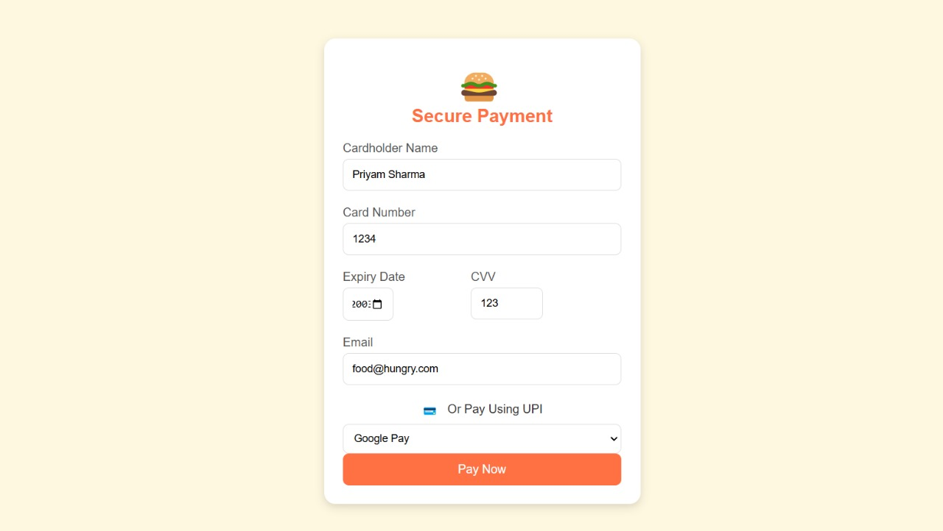

**5.7 Food Items:**

This interface page is designed to showcase food items in an organized and user-friendly manner. Each dish is displayed as a card with:

* A **high-quality image** for visual appeal.
* The **name** of the dish, its **price**, and a short **description**.
* A prominent red **"Order" button** for users to quickly select items.

### ****How It Works****:

1. Users can **scroll** through the grid to view available dishes.
2. Clicking the **"Order" button** adds the item to their cart or initiates the checkout process.
3. The selected items can then be finalized for delivery or pickup.

This layout ensures easy navigation and a smooth ordering experience.

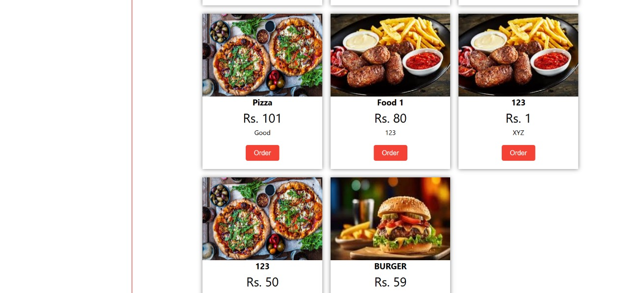

**5.8 Login Page:**

This is a Login Page designed for a web application. It features a simple, clean, and user-friendly interface with a minimalist design. The page contains:

* Username Input Field – where users enter their unique username.
* Password Input Field – a secure field to input the user's password.
* Login Button – allows users to submit credentials to log into the application.
* Register Button – provides users an option to navigate to the registration page to create a new account.

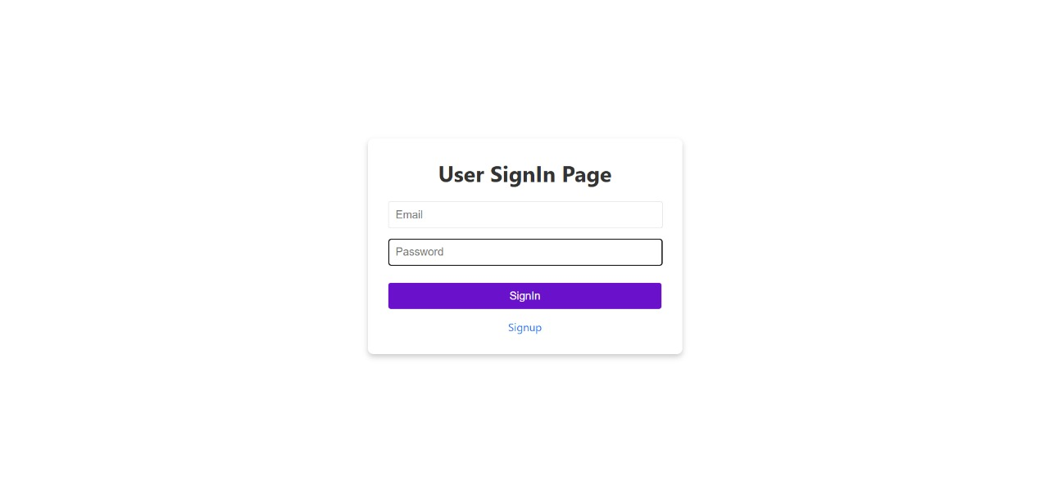

**5.9 Admin Page:**

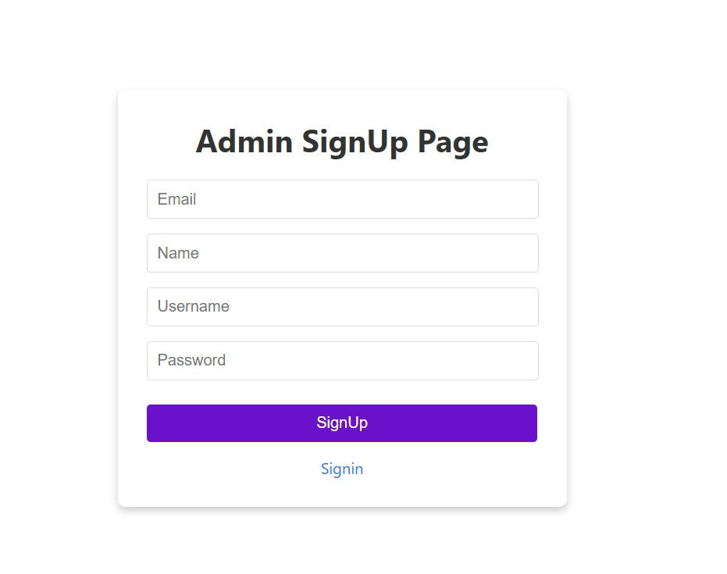

This is an **Admin Sign-Up Page** interface, designed to allow administrators to create their accounts. Here's how it works:

### ****Elements of the Interface:****

1. **Title**: "Admin SignUp Page" clearly indicates the purpose of the form.
2. **Input Fields**: Four text fields for collecting user information:
   * **Email**: For the administrator's email address.
   * **Name**: Full name of the administrator.
   * **Username**: A unique username for the admin account.
   * **Password**: A secure password to protect the account.
3. **Sign-Up Button**: A **purple "SignUp" button** for submitting the form once all fields are filled.
4. **Sign-In Link**: A clickable **"Signin"** link below the button, redirecting users to the login page if they already have an account.

### ****How It Works:****

1. **Input Validation**:
   * The user enters their details in the provided fields.
   * Validation checks ensure proper data format (e.g., a valid email address, secure password).
2. **Submit Action**:
   * When the "SignUp" button is clicked, the form data is submitted to the server.
   * The server processes the data and stores it in the database if valid.
3. **Success or Error Message**:
   * On successful sign-up, the user is notified and redirected to the login page or admin dashboard.
   * If there’s an error (e.g., missing fields or duplicate username), an appropriate error message is displayed.
4. **Sign-In Option**:
   * Users with an existing account can click the "Signin" link to navigate to the login page.

### ****Purpose****:

This page ensures a secure and organized way to register administrators on the platform, enabling access control and account management.

### Chapter 6

### Project Outcome

The outcome of the Hunger Bites project will be a fully functional food delivery app that meets the needs of both customers and local restaurants. By focusing on convenience, accessibility, and sustainability, the app aims to improve the food delivery experience for users and support small businesses.

**1. Improved Customer Experience:**  
One of the primary outcomes is a user-friendly app that allows customers to easily browse restaurant menus, place orders, make payments, and track deliveries in real time. The app will provide convenience to customers by saving time and effort, especially for those with busy schedules or limited access to transportation. Features like personalized recommendations, quick ordering, and reliable customer support will enhance the overall experience.

**2. Support for Local Restaurants:**  
Another key outcome is the support it provides to local restaurants. By offering a platform for food delivery, Hunger Bites helps small restaurants reach a broader audience without needing to create their own delivery systems. This can help increase their sales and grow their customer base, contributing to the success of local businesses.

**3. Job Creation and Economic Impact:**  
The app will also create job opportunities for delivery drivers, customer support teams, and restaurant staff. This not only helps individuals find employment but also supports the local economy by promoting business growth and providing income-generating opportunities.

**4. Promotion of Sustainability:**  
The project will focus on sustainability by encouraging the use of eco-friendly packaging and reducing food waste. The app’s partnerships with restaurants that prioritize environmentally friendly practices will help raise awareness about sustainability and promote responsible consumption among users.

In conclusion, the Hunger Bites project aims to deliver a practical and sustainable food delivery solution that benefits customers, restaurants, employees, and the environment, creating a positive impact on the community.

### References

The references or bibliography section lists all the sources of information used in the research or project. This helps to give credit to the original authors and allows others to find the sources for further reading. In the Hunger Bites project, various types of resources such as books, articles, websites, and studies were used to gather information about food delivery trends, app development, and market research.

**1. Books and Academic Articles:**  
Books and academic journals related to app development, food delivery services, and e-commerce were used to understand best practices and the technologies required to build a successful food delivery app. These sources provided valuable information on designing user-friendly interfaces, developing secure payment systems, and creating efficient delivery processes.

**2. Market Research Reports:**  
Reports on food delivery industry trends helped to analyze the current market and competition. These reports provided insights into customer preferences, popular food delivery features, and business models of successful companies. They also helped understand the growing demand for food delivery services and the shift toward online ordering.

**3. Online Articles and Websites:**  
Various online articles, blog posts, and websites were consulted to learn about the latest trends in mobile app development, food delivery services, and sustainability practices. Websites of successful food delivery apps, such as Uber Eats and DoorDash, were also studied to understand their features, strengths, and challenges.

**4. Interviews and Surveys:**  
To gain a better understanding of the needs and expectations of customers and restaurant owners, interviews and surveys were conducted. These provided firsthand information on what people want in a food delivery app and how it could improve their experience.

In summary, the references and sources used in this project played a critical role in shaping the development and design of Hunger Bites, ensuring that the app meets the needs of customers, supports local businesses, and follows industry trends.